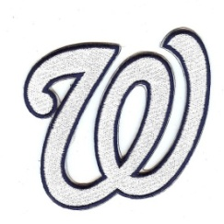Wharton Wildcats 2013 BASEBALL SCHEDULE

Date | Opponent
Tue Feb 12 | @ Armwood
Fri Feb 15 | Freedom (BRAWL ON BRUCE B DOWNS)
Tue Feb 19 | @ Newsome *
Fri Feb 22 | Alonso *
Sat Feb 23 | @ Riverview (1pm)
Tue Feb 26 | Plant *
Fri Mar 01 | Bloomingdale *
Tue Mar 05 | @ Steinbrenner
Thu Mar 07 | Gaither (Alumni Battle)
Sat Mar 9-15  Tue Mar 19 | Saladino Tournament  @ Durant *
Fri Mar 22 | Newsome *
Tues Mar 26 | @ Alonso *
Thur Mar 28 | @ Plant *
Tue Apr 02 | @ Bloomingdale *
Fri Apr 05 | Durant *
Tue Apr 9 | @ Lennard
Fri Apr 12 | Blake
Tues Apr 16  Fri Apr 19 | Sickles  @ Chamberlain
Mon Apr 22 8A-7 District Tournament Begins @ Bloomingdale
*Indicates 8A-7 District Rivalry Game
All Games begin at 7pm unless noted.

